Lancashire’s Eight Strategic Steps to Guide the Direction and Development of the Primary PE and Sport Premium
2018/20

www.lancashire.gov.uk

Step 1 - Vision
Think about the Vision of the school, links to school development planning, the development of the school and PE
curriculum.

Step 2 -
Audit
PE – What is the Quality of provision? Who delivers it? What is the level of attainment of the pupils?
School Sport – what is the Quality of provision? Who delivers it? What’s the impact on pupils?
Physical Activity How EFFECTIVE is the physical activity provision outside of the PE curriculum?

Step 3 - Strengths

1
What does the school want to see achieved through the PE Premium?

2
What is the current provision of:

3
Step 5 - Action Planning
Create action plans that guide the direction and work of lead personnel mapped to the 5 key indicators of the Primary PE and Sport Premium.
Identify the intended impact on the pupils
What actions need to be taken to achieve the intended impact?
Identify the evidence which will show the intended impact.
Each key indicator with significant annual milestone targets identified (Use the PE and Sport Premium Template)

Step 6
Has the intended impact on pupils being achieved?
Have we developed the areas identified? Each key indicator with significant annual milestone targets identified
(Use the PE and Sport Premium Template)
Implement monitoring, evaluation and review systems of the intended impact identified are in place.

Step 7 - Celebrate

Physical Education KS1, KS2
School Sport – (Out of hours, extra-curricular sport, competitive sport and School Games)
Physical Activity – (30 mins across the school day,
wake & shake, Active mile etc)
Which areas require developing to achieve the schools
What are the schools significant strengths.
Improvements in PE? School Sport/competitions? Physical Activity?
Celebrate success
Website and reporting online. (Grant requirement)

longer-term vision?
5
What do we need to do? What will the intended impact be?
6
Are we achieving what we set out to develop?
7
What has been achieved?
Celebrate success
8
What still needs to be done?

Step 4 - Development
Identify from the information from Step 2 & 3 the
priority areas of development.
Create a long-term strategic plan (2/3 year plan) with the identified priority areas mapped to the 5 key indicators of the Primary PE and Sport Premium based on audit of strengths and areas of development.
4
Which areas require change to achieve the schools longer-term
vision?
Who can help?
Awards achieved

Step 8 - Next Steps
Evaluate and synthesise
Judgements reviewed against STEP 1 outcomes.

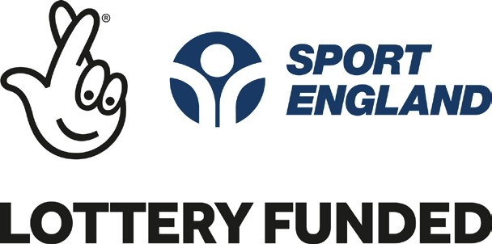Primary PE and Sport Premium

The revised DfE guidance on the Primary PE and Sport Premium includes the 5 Key Indicators across which schools should demonstrate an improvement. The Eight Strategic Steps will help guide the Direction and development of the premium. These steps will help schools reflect on what additional and sustainable improvements to PE, Sport and physical activity will benefit their school and children.å
It is recommended to use the “Evidencing the Impact of the Primary PE and Sport Premium” website reporting tool document and regularly update it throughout the year, as evidence of your on-going review and impact.
Examples of how you can evidence the impact of your spending

DATA COLLECTION

- Numbers of children attending out of hours activities on a weekly basis. (i.e. extra curricular sports, change4life, wake and shake)
- List of clubs each child is attending and pupils not attending any club.
- School games participation at festivals, events and Level 2 competitions.
- School games Level 1 participation.
- Active mile participation

STAFF AUDITS AND CPD

- Ask school staff to complete an audit of their confidence and/or knowledge in teaching the different activity areas of PE.
- Arrange CPD for school staff based on results from the audit. Use the audit as a baseline. After the intervention (CPD) ask the staff to complete the audit again to see if there is any impact on the teacher from the arranged CPD.
- What is the impact on the children from the teacher receiving the CPD and support?

PUPILS

ASSESSMENT

- PE Assessment – Baseline Y1, tracking progress through Lancashire core tasks.
- Lesson observations for PE to measure impact of an intervention.
- Pupil progress reports
- Assess improvements after an interven- tion (CPD) or initiative – take baseline measurement, re-measure after ½ term, term, academic year.
- Case study

- Ask the children for their attitudes/opinions of PE and what is offered out of hours.
- How being active makes them feel? Does the active mile or wake and shake have an effect on their concentration back in the classroom?

