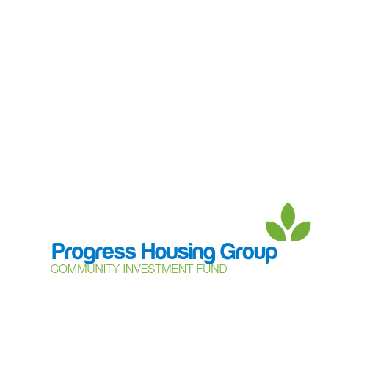

**Community Investment Fund – Emergency Community Support.**

Are you part of a community group, charity or network that requires funding to help support your local community during the current virus pandemic?

Progress Housing Group are offering small amounts of funding to help in these times of crisis. All applications will be dealt with upon receipt and we are working to make the process simple, so that funding can be issued in a timely way.

**Contact details** – who can we contact to discuss the application?

|  |  |
| --- | --- |
| Contact name |  |
| Contact number(s) |  |
| E-mail |  |

**Organisation/Charity/Group –** are you applying on behalf of an organisation, group or charity?

|  |  |
| --- | --- |
| Organisation Name |  |
| Charity/Company number (if applicable) |  |

**Tell us what you would like to do!**

|  |
| --- |
| What do you need funding for? |
| Which area will you be supporting? (geographical area) |
| How much funding do you require? |
| When will the funding be used? (Timescales) |
| We love to hear how the Community Investment Fund has helped and supported people who can we contact for this information? |

**Please return your application to** [**community@progressgroup.org.uk**](mailto:community@progressgroup.org.uk)

**Progress Housing Group, Sumner House, 21 King Street, Leyland, PR25 2LW**

**Tel: 03333 204 555**