Active Lancashire- Bowls development
Active Lancashire have been working in partnership with Burnley Bowls Partnership, British Crown Green Bowls Association (BCGBA) and Burnley School Sports Partnership (SGO) to develop a new cohort of volunteers and leaders to support with the Burnley Inter School Games events, School Games County festivals and with the development of Bowls within Burnley.
In February 2020 the BCGBA through VLC funding delivered an Activator training course to 30 Bowls club members from 12 different clubs. All volunteers were over the age of 25 and the majority of the volunteers were over the age of 60. The aim of the training was to:
- Develop a cohort of volunteers to support a KS2 Special schools bowls festival in March 2020 and local Burnley Inter events.
- Upskill recreational members to support the development of bowls and in particular junior bowls in Burnley.
- Provide a community exit route for young people from the School Games.
- Have a new cohort of volunteers involved in the Spar Lancashire School Games and provide an intergenerational experience for participants.
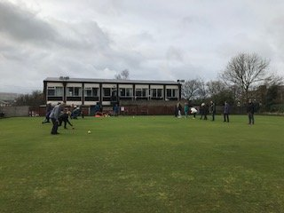
Co-Ordinator for the Burnley Bowls Partnership and School Games Bowls volunteer said: “We learned welcoming techniques, the importance of Safeguarding and were given the opportunity to share ideas and experiences with each other. All this will benefit the Partnership because all clubs will be working together to deliver the sessions at events such as the school games to get young people interested in the sport we love. I think everyone thoroughly enjoyed the day and will give them lots of tools to use going forwards.”
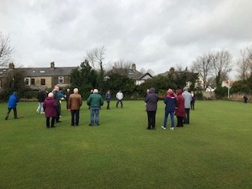
Active Lancashire want to ensure the Spar Lancashire School Games workforce is diverse and representative of the Lancashire population. We identified a need to develop volunteers over the age of 25 and this training helped support this.
“The volunteers will support the delivery of an inter-schools bowling festival in summer term, they will deliver fun skill sessions as well as introducing bowling to new young people who will not have taken part before. The volunteers will also provide access to local clubs for schools to use during extended provision.” Helen Tyson, Burnley School Sports Partnership & SGO.

Active Lancashire- Supporting SEND Students (Foundation Learning-Myerscough College)
Active Lancashire in January 2020 delivered two separate training courses to students at Myerscough College as part of the VLC, Department for Education funding. The courses delivered were; First Aid and First Steps into Coaching.
The 13 foundation learning students (12 Males, 1 Female) all on the SEND register and Myerscough College support workers attended both training days and will support a number of inter school games events and the SPAR Lancashire School Games Table Tennis county festival in March 2020.
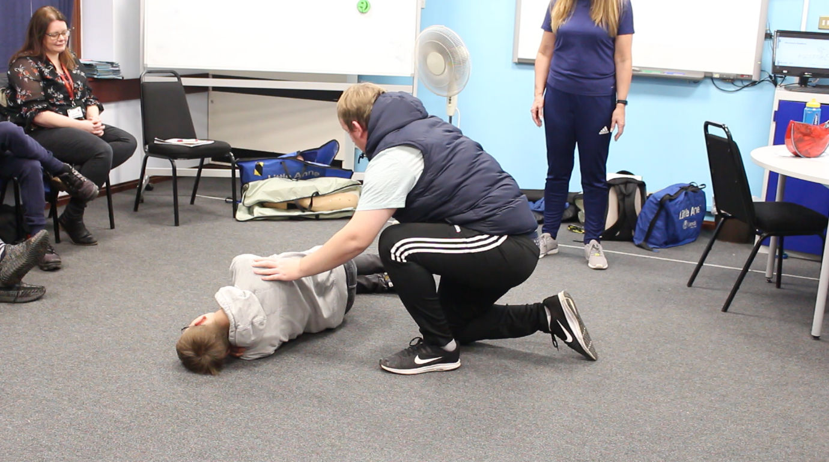
“The students have been able to acquire some valuable learning and qualifications from the training attended. The two days of training will support them in the future, improve their employment prospects and provide much needed assistance in the delivery of School Games events. The training has brought out confidence and a willingness to volunteer in the future.” Active Lancashire
As part of Active Lancashire’s delivery plan developing and giving more opportunities to those on the SEND register was a priority and training these students helps us achieve this.

Active Lancashire- Chorley School Sport Partnership Volunteer
Active Lancashire over the last few years have worked closely with England Handball and Chorley School Sports Partnership to develop Handball within the county. This has led to the first Handball Community Club being created, a number of Satellite Clubs and Handball within the SPAR Lancashire School Games programme.
For the first time in 2020 we increased our Handball programme in the School Games to U13 Boys & Girls, in addition to the U15’s competitions which have been running for a number of years. To help with his growth we’ve continued to work with Uclan to develop a cohort of the sports coaching students, however we also widened our training offer to an enthusiastic 1st year student from Runshaw College, who has been supporting the Chorley School Games.
“The handball training has helped me lots over the last couple of months. I have found a real passion for the sport and I am hoping that I can carry on with what I’m doing and hopefully I am able to progress on and gain further qualification in both coaching and officiating”. Through the VLC training the student from Runshaw College has been able to attend Safeguarding and first aid training also.
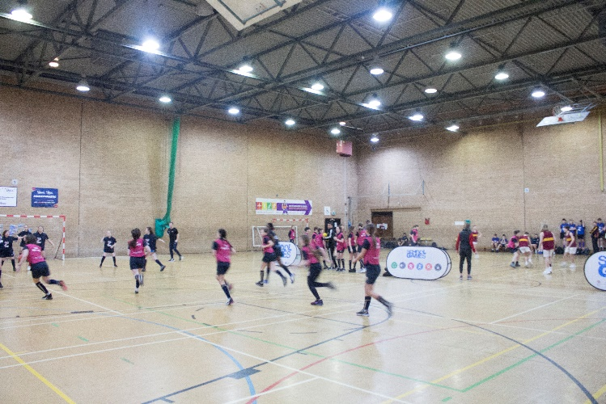
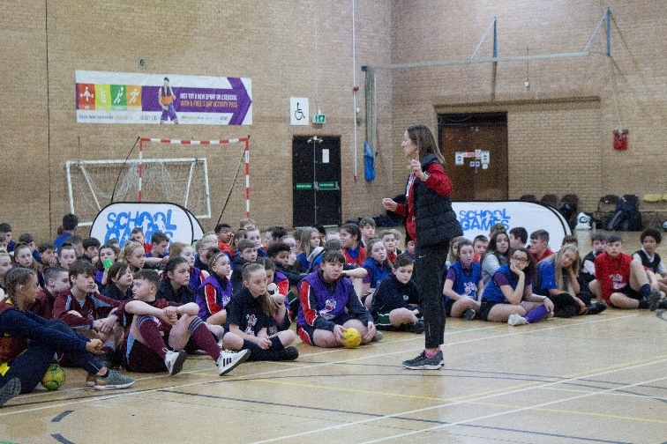
Gemma Stokes, Chorley SSP said: “Our leader worked in the Chorley area for a little over a year. He got involved with the School Games as a volunteer helping at his previous high school. He attended a School Games event and was really enthused to be part of it.

We approached Active Lancashire to access support from the DfE funding to formally develop his skills further and help him obtain some qualifications to take him forward with a future career and further assist the School Games in Chorley. He has attended a refereeing course and safeguarding then was invited to support the County Handball final, which again could not have been delivered without him. He was brilliant. Just a little bit of help and recognition has boosted his self-confidence and he has found something he really excels at. Our leader must have volunteered over 200 hours, he does at least 3-4 hours per week and 26 of those have been spent at the Handball league in October and November alone.

The next step is assisting with the development of a Community Handball Club and now he has more qualification and experience he will continue to give back to his High School and the School Games in Chorley.”

